**DATA ANALYTICS PROJECT USING EXCEL**

Skills

Data cleaning, data processing, data analytics, data visualization, creating report (interactive dashboard), insights and next steps

Objective

Vrinda store wants to create an annual sales report for 2023. So that, Vrinda can understand their customers and grow more sales in 2024.

Questions

1. Compare the sales and orders using single chart
2. Which month got the highest sales and orders?
3. Who purchased more-men or women in 2023?
4. What are the different order status in 2023?
5. List top 5 states contributing to the sales?
6. Relation between age and gender based on a number
7. Which channel is contributing to max sales?
8. Highest selling category?

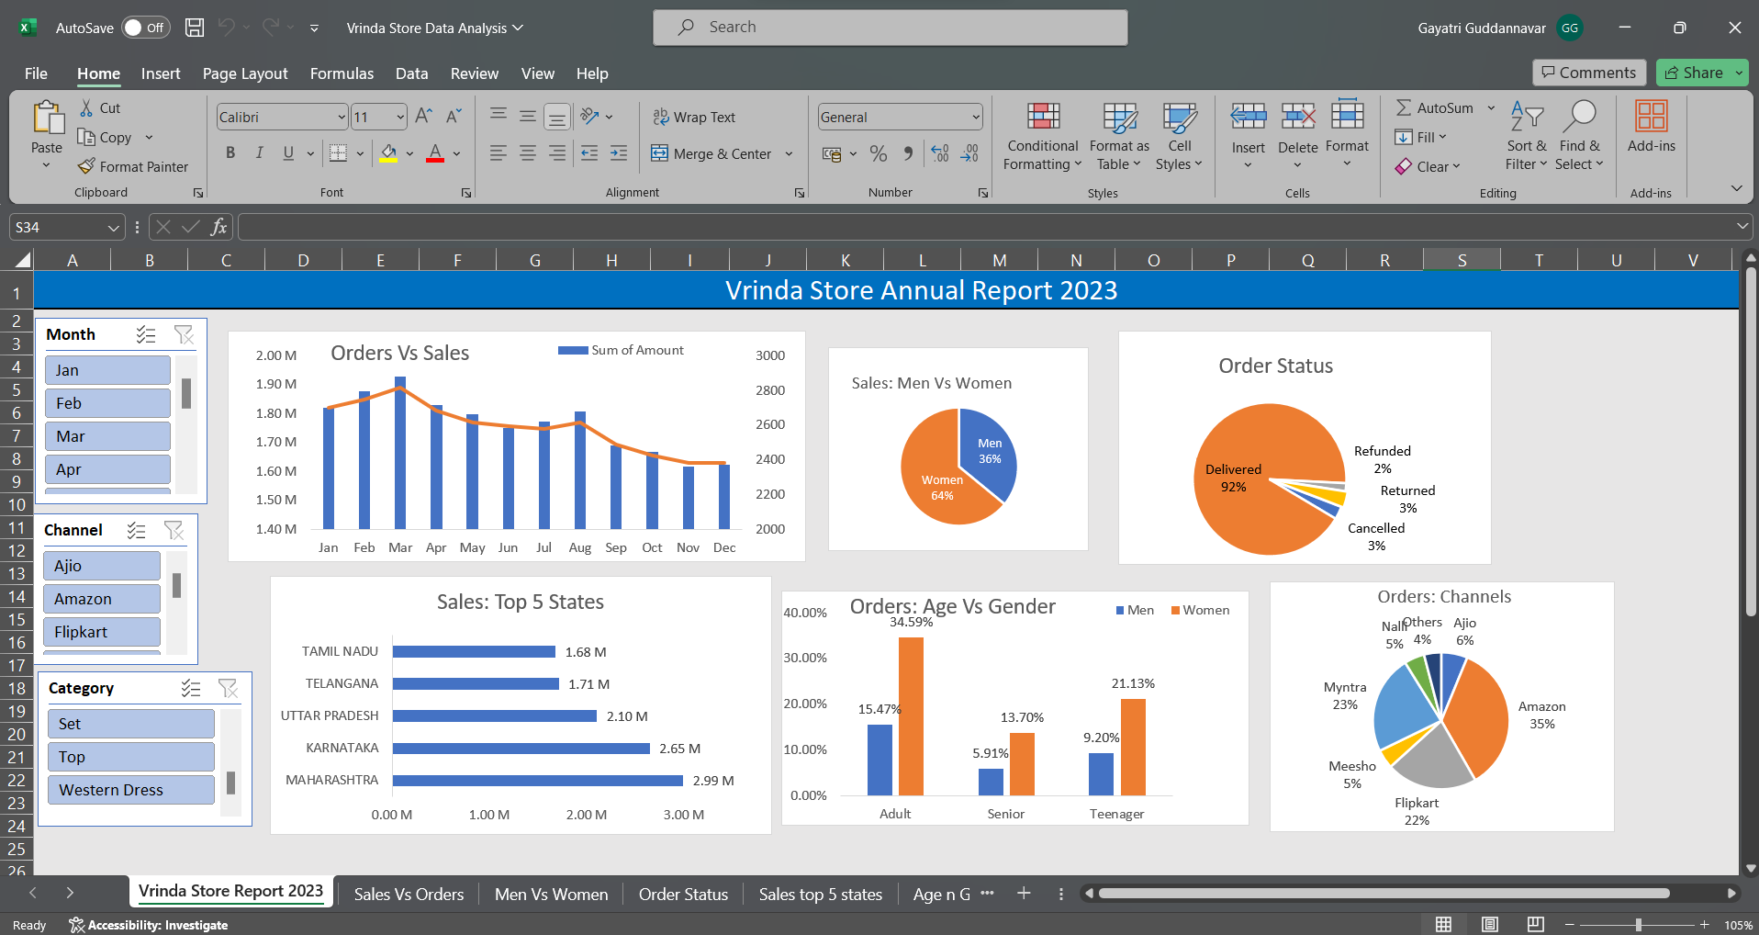

Complete project link:

<https://1drv.ms/x/c/4eda3eb7e5131cb1/EbHdLBC5BV9NrY2hbf8jsOoBpYCk4fek0RuPAx3UZnhslw?e=Gr6hkt>

Insights:

* Women are more likely to buy compared to men (-65%)
* Maharashtra, Karnataka and Uttar Pradesh are the top 3 states (-35%)
* Adult age group (30-49 yrs) is max contributing (-50%)
* Amazon, Flipkart and Myntra channels are max contributing (-80%)

**Final Conclusion to improve Vrinda store sales:**

* Target **women** customers of age group (**30-49** yrs) living in **Maharashtra, Karnataka and Uttar Pradesh** by showing ads/offers/coupons available on **Amazon, Flipkart and Myntra**